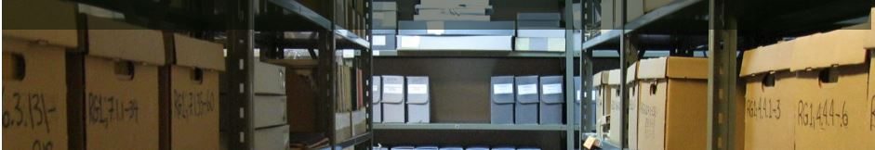
January 2023
Image courtesy of the Sam Waller Museum

Introducing our Board
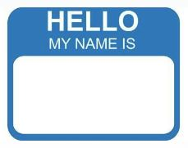
Chair: Andrew Morrison
Vice-Chair: Heather Bidzinski
Finance and Grants: Katrin Nielsdottir
Secretary: Jackson Anderson
Digital Initiatives: Jackson Anderson and Katie Lynch
Education: Al Thorleifson
Indigenous Relations: Carmen Miedema and Mary Horodyski
Information and Outreach: Corser du Pont
Membership: Carmen Miedema and Heather Bidzinski
Student Member-at-large: Blake Mueller

Call for New Board Member
Special Initiatives Member-at-Large: We are seeking a Member-at-Large to assist in organizing the Manitoba Day event. This can be a shared position.

Committee Reports
Digital Initiatives: We are developing accessibility standards for our Zoom events. We are also assisting members with renewing or starting membership online. See Renewing and Starting Membership in this newsletter.
Education and Advisory Services: Members of the AMA can expect to hear about our planned workshop on Archiving Digital Media within the coming month. The presentation will look at recent experiences of several organizations to undertake archiving of digital media, what to save, and how to do so.
Finance and Grants: The Association for Manitoba Archives Fund, supported by Endow Manitoba and administered by The Winnipeg Foundation, provides the AMA with a reliable source of operating income today and in future years as we continue to build capital through ongoing contributions. To learn more about this fund and the opportunity to donate to it, please follow this link: https://www.mycharitytools.com/gift/wpgfdn/donate?fund=894
Indigenous Relations: Please save February 8 at 7 pm for a webinar on “Creating a Meaningful Land Acknowledgment” with Allen Sutherland, also known as Waabiskhi Mazinazoot Mishtaatim, or White Spotted Horse. Registration is on Eventbrite: https://www.eventbrite.com/e/creating-a-meaningful-land-acknowledgment-tickets-519134424037
Information and Outreach: Stay tuned for news about an online Trivia night in February!
Membership Committee: We are starting the process of reviewing membership categories and fees. We hope to have a formal proposal completed by March 1st and look forward to hearing your feedback once it is available.
Student Member-at-Large: Plans are underway to renew the Association of Canadian Archivists (ACA) student chapter.

Renewing and Starting Membership online
A reminder that membership renewals are due on April 1, 2023. Please follow the instructions below to renew online. Please contact the AMA at ama1@mts.net or Digital Initiatives at webmaster@mbarchives.ca if you have any difficulties.
Membership renewals can be completed by logging into the website clicking on "View profile" in the top right-hand corner of the page. In your profile, click on the "Renew to [date]" button. Update your information in the fields that appear as needed and click the "Update and next" button. Review your information and click the "Pay online button" to finalize your renewal in PayPal.

“Creating a Meaningful Land Acknowledgement” with Allen Sutherland / Waabiskhi Mazinishin Mishtadim (White Spotted Horse)
The AMA is pleased to invite you to this free webinar presented in collaboration with the Treaty Relations Commission of Manitoba. Date: Wednesday, February 8, 2023 at 7 pm on Zoom. Register here: https://www.eventbrite.com/e/creating-a-meaningful-land-acknowledgment-tickets-519134424037

Focus on Treaties
“What's Your Treaty Story?” Treaty Relations Commission of Manitoba. https://storymaps.arcgis.com/stories/3a6048e38dae4afd8def879b63f2b1b5
“Interactive treaty education facility Agowiidiwinan Centre opens at The Forks in Winnipeg” by Darren Bernhardt, CBC News, Dec 15, 2022.. https://www.cbc.ca/news/canada/manitoba/agowiidiwinan-treaty-centre-open-forks-winnipeg-1.6686978
“Treaties and the Treaty Relationship Webinar Series” Canada’s History. https://www.canadashistory.ca/explore/webinars/treaties-and-the-treaty-relationship-webinar-series

News about our Members
The Jewish Heritage Centre of Western Canada is pleased to announce the official reopening of the completely renovated Freeman Family Holocaust Education Centre (HEC). New additions to the HEC include an interactive table featuring stories and photographs outlining the lives of local survivors before, during, and after the Holocaust, and a computer kiosk connecting visitors to the USC Shoah Foundation’s Visual History Archive (VHA) and its more than 55,000 video testimonies and a list of 1.9 million searchable names. The Jewish Heritage Centre is the only full access site to the VHA between Toronto and Calgary.
For more information, please visit the Jewish Heritage Centre of Western Canada website: https://www.jhcwc.org/

Krystal Payne has an article in the current Fall/Winter 2022 issue of Archivaria titled “Archival Harm Reduction: A Theoretical Framework for Utilizing Harm-Reduction Concepts in Archival Practice.” Read the article here: https://archivaria.ca/index.php/archivaria. You can also read her M.A. thesis “Archival harm reduction: utilizing public health harm reduction concepts for reconciliatory power shifts in archives” here : https://mspace.lib.umanitoba.ca/handle/1993/35762

Lieutenant Governor’s Award for Historical Preservation and Promotion
Nominations are open until Friday, March 3, 2023 for the Lieutenant Governor’s Award for Historical Preservation and Promotion. Initiated in 2011 and presented with the Manitoba Historical Society, this award recognizes “people who have rendered prolonged, meritorious service in the preservation and promotion of Manitoba’s history and heritage”. For more information, see the Manitoba Historical Society website at http://www.mhs.mb.ca/info/awards/lg/index.shtml

Call for Volunteers
We are always looking for members to join our committees. Volunteering with the AMA is an excellent way to network with archivists, build skills, and shape the future of archives in Manitoba. If you are interested, please contact the Chair, or a committee chair, at one of the email addresses listed on this page https://mbarchives.ca/contact

News for the newsletter?
Does your archive have a new grant or a new hire? Or do you have a collection you want to promote? Send your news to ama1@mts.net and we will include it in an upcoming newsletter.

